caffeine.R

Samuel

Wed Oct 31 14:10:22 2018

# Sam Tenney  
# Homework 8  
# Caffeine.R  
  
# Read in the data from https://blades.byu.edu/stat230data/caffeine.txt  
caffeine <- read.table(text = "run sweetener carbonation taste  
 1 CornSyrup No 189  
 2 Aspertame No 187  
 3 CornSyrup Yes 191  
 4 AceK Yes 173  
 5 Aspertame Yes 171  
 6 AceK No 180  
 7 Sugar No 187  
 8 CornSyrup Yes 184   
 9 Aspertame No 187  
10 AceK No 185  
11 Sugar No 190  
12 AceK Yes 163  
13 Sugar Yes 198  
14 Sugar Yes 199  
15 CornSyrup No 182  
16 Aspertame Yes 178", header = TRUE, sep = '')  
  
str(caffeine)

## 'data.frame': 16 obs. of 4 variables:  
## $ run : int 1 2 3 4 5 6 7 8 9 10 ...  
## $ sweetener : Factor w/ 4 levels "AceK","Aspertame",..: 3 2 3 1 2 1 4 3 2 1 ...  
## $ carbonation: Factor w/ 2 levels "No","Yes": 1 1 2 2 2 1 1 2 1 1 ...  
## $ taste : int 189 187 191 173 171 180 187 184 187 185 ...

head(caffeine)

## run sweetener carbonation taste  
## 1 1 CornSyrup No 189  
## 2 2 Aspertame No 187  
## 3 3 CornSyrup Yes 191  
## 4 4 AceK Yes 173  
## 5 5 Aspertame Yes 171  
## 6 6 AceK No 180

tail(caffeine)

## run sweetener carbonation taste  
## 11 11 Sugar No 190  
## 12 12 AceK Yes 163  
## 13 13 Sugar Yes 198  
## 14 14 Sugar Yes 199  
## 15 15 CornSyrup No 182  
## 16 16 Aspertame Yes 178

# Calculate the summary statistics for each treatment  
aggregate(taste~sweetener+carbonation, data = caffeine, FUN = mean)

## sweetener carbonation taste  
## 1 AceK No 182.5  
## 2 Aspertame No 187.0  
## 3 CornSyrup No 185.5  
## 4 Sugar No 188.5  
## 5 AceK Yes 168.0  
## 6 Aspertame Yes 174.5  
## 7 CornSyrup Yes 187.5  
## 8 Sugar Yes 198.5

aggregate(taste~sweetener+carbonation, data = caffeine, FUN = sd)

## sweetener carbonation taste  
## 1 AceK No 3.5355339  
## 2 Aspertame No 0.0000000  
## 3 CornSyrup No 4.9497475  
## 4 Sugar No 2.1213203  
## 5 AceK Yes 7.0710678  
## 6 Aspertame Yes 4.9497475  
## 7 CornSyrup Yes 4.9497475  
## 8 Sugar Yes 0.7071068

# Create side-by-side dotplots of the response for the different treatments  
library(lattice)  
dotplot(taste~sweetener|carbonation, data = caffeine, main = "Dotplots of Taste Scores")

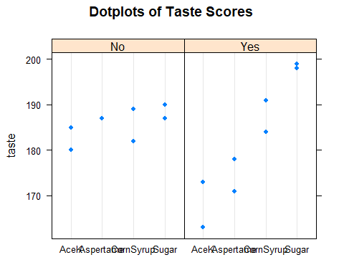

# Create ANOVA table   
caffeineFacMod <- aov(taste~sweetener+carbonation+sweetener:carbonation, data = caffeine)  
anova(caffeineFacMod)

## Analysis of Variance Table  
##   
## Response: taste  
## Df Sum Sq Mean Sq F value Pr(>F)   
## sweetener 3 734.50 244.833 13.8913 0.001545 **  
## carbonation 1 56.25 56.250 3.1915 0.111840   
## sweetener:carbonation 3 414.25 138.083 7.8345 0.009132 **  
## Residuals 8 141.00 17.625   
## ---  
## Signif. codes: 0 '***' 0.001 '**' 0.01 '*' 0.05 '.' 0.1 ' ' 1

# Create table of 95% confidence intervals for all pair-wise comparisons of factor and interaction levels  
TukeyHSD(caffeineFacMod, which="sweetener:carbonation")

## Tukey multiple comparisons of means  
## 95% family-wise confidence level  
##   
## Fit: aov(formula = taste ~ sweetener + carbonation + sweetener:carbonation, data = caffeine)  
##   
## $`sweetener:carbonation`  
## diff lwr upr p adj  
## Aspertame:No-AceK:No 4.5 -12.1127398 21.1127398 0.9465629  
## CornSyrup:No-AceK:No 3.0 -13.6127398 19.6127398 0.9937505  
## Sugar:No-AceK:No 6.0 -10.6127398 22.6127398 0.8227965  
## AceK:Yes-AceK:No -14.5 -31.1127398 2.1127398 0.0950689  
## Aspertame:Yes-AceK:No -8.0 -24.6127398 8.6127398 0.5810259  
## CornSyrup:Yes-AceK:No 5.0 -11.6127398 21.6127398 0.9140444  
## Sugar:Yes-AceK:No 16.0 -0.6127398 32.6127398 0.0601896  
## CornSyrup:No-Aspertame:No -1.5 -18.1127398 15.1127398 0.9999214  
## Sugar:No-Aspertame:No 1.5 -15.1127398 18.1127398 0.9999214  
## AceK:Yes-Aspertame:No -19.0 -35.6127398 -2.3872602 0.0246064  
## Aspertame:Yes-Aspertame:No -12.5 -29.1127398 4.1127398 0.1743365  
## CornSyrup:Yes-Aspertame:No 0.5 -16.1127398 17.1127398 1.0000000  
## Sugar:Yes-Aspertame:No 11.5 -5.1127398 28.1127398 0.2342184  
## Sugar:No-CornSyrup:No 3.0 -13.6127398 19.6127398 0.9937505  
## AceK:Yes-CornSyrup:No -17.5 -34.1127398 -0.8872602 0.0383078  
## Aspertame:Yes-CornSyrup:No -11.0 -27.6127398 5.6127398 0.2704638  
## CornSyrup:Yes-CornSyrup:No 2.0 -14.6127398 18.6127398 0.9994824  
## Sugar:Yes-CornSyrup:No 13.0 -3.6127398 29.6127398 0.1500109  
## AceK:Yes-Sugar:No -20.5 -37.1127398 -3.8872602 0.0159894  
## Aspertame:Yes-Sugar:No -14.0 -30.6127398 2.6127398 0.1107351  
## CornSyrup:Yes-Sugar:No -1.0 -17.6127398 15.6127398 0.9999949  
## Sugar:Yes-Sugar:No 10.0 -6.6127398 26.6127398 0.3567804  
## Aspertame:Yes-AceK:Yes 6.5 -10.1127398 23.1127398 0.7667317  
## CornSyrup:Yes-AceK:Yes 19.5 2.8872602 36.1127398 0.0212838  
## Sugar:Yes-AceK:Yes 30.5 13.8872602 47.1127398 0.0012663  
## CornSyrup:Yes-Aspertame:Yes 13.0 -3.6127398 29.6127398 0.1500109  
## Sugar:Yes-Aspertame:Yes 24.0 7.3872602 40.6127398 0.0061540  
## Sugar:Yes-CornSyrup:Yes 11.0 -5.6127398 27.6127398 0.2704638

# Check Assumptions  
# Calculate Residuals  
caffeine$resids <- resid(caffeineFacMod)  
mean(caffeine$resids)

## [1] 1.249001e-16

# Index Plot: Check Independence  
plot(caffeine$resids, type="b")  
abline(h=0)

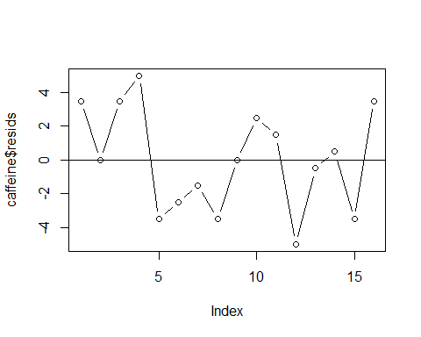

# Normal qq plot: check normality  
qqnorm(caffeine$resids)  
qqline(caffeine$resids)

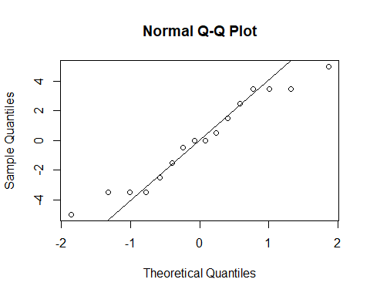

# Ratio of sds: check equal variance  
aggregate(taste~sweetener+carbonation, data = caffeine, FUN = sd)

## sweetener carbonation taste  
## 1 AceK No 3.5355339  
## 2 Aspertame No 0.0000000  
## 3 CornSyrup No 4.9497475  
## 4 Sugar No 2.1213203  
## 5 AceK Yes 7.0710678  
## 6 Aspertame Yes 4.9497475  
## 7 CornSyrup Yes 4.9497475  
## 8 Sugar Yes 0.7071068